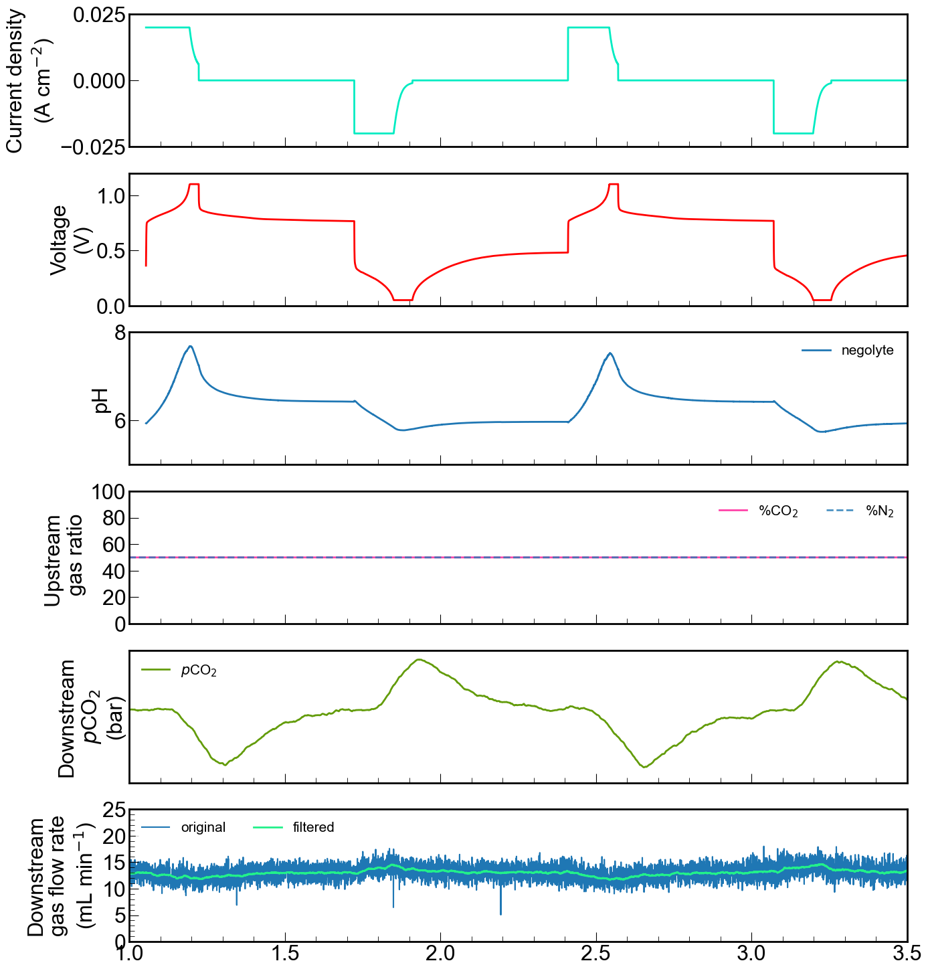

Rest

Rest

Discharge

Charge

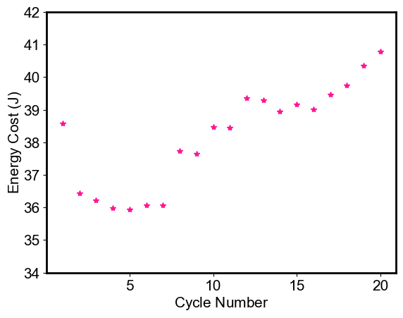

**Energy Cost, cycle 1 = 38.58 Joule**

**Energy Cost, cycle 20= 40.78 Joule**

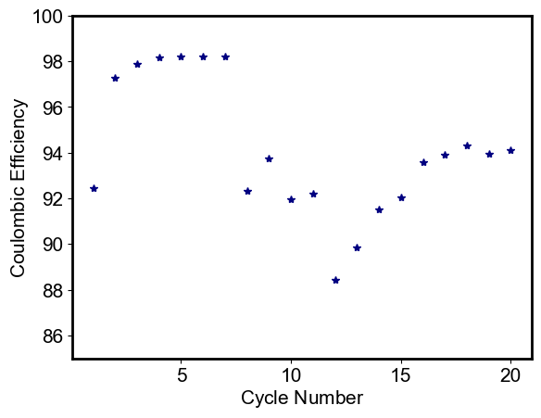

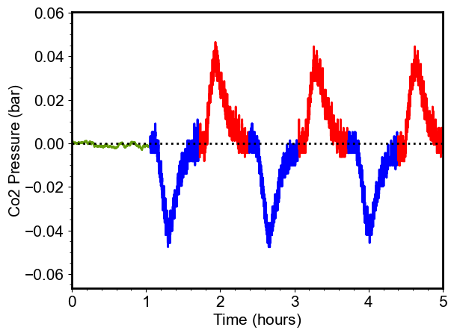

Martin’s method:

Integrate from the flow mass controller: Find volume in ml

Use ideal gas law: divide ml/22.4 to find mmol of co2

Energy cost: kJ/mol (kJ from the charge/discharge curves)

**Theoretical amount of co2 we should have captured:**

The experiment was done with 10 ml of 0.05 M btmapaq corresponding to 96 C capacity. Because of 65% purity we expect an accessed capacity of 62.4 C -🡪 the real accessed capacity is as shown below:

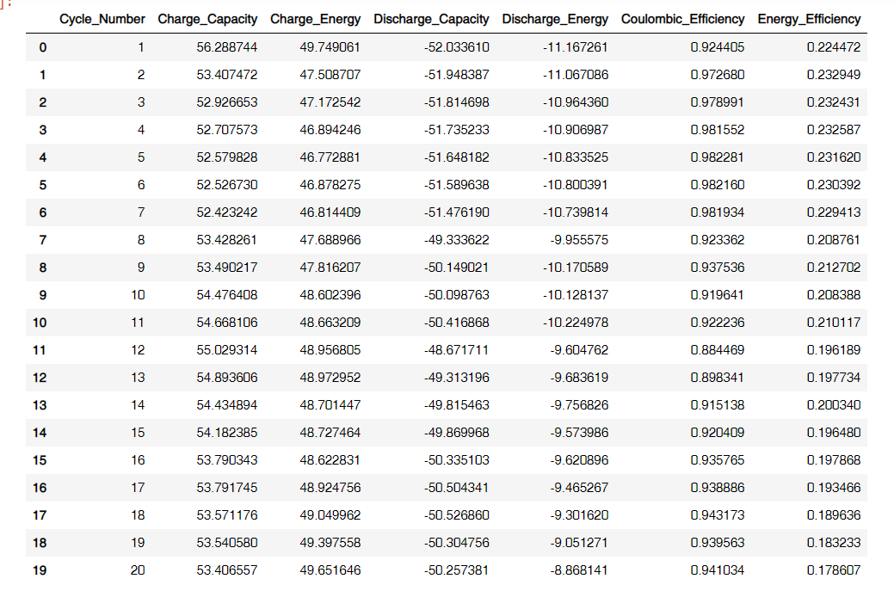

We have accessed around 85%-89% of capacity in each cycle (0.000325 mols of btmapaq in 10 ml). We expect each moles of btmap-aq to capture 2 moles of co2. So we expect theoretically to have captured 0.00055 moles of co2. Below the theoretical moles of co2 expected based on each cycle is shown.

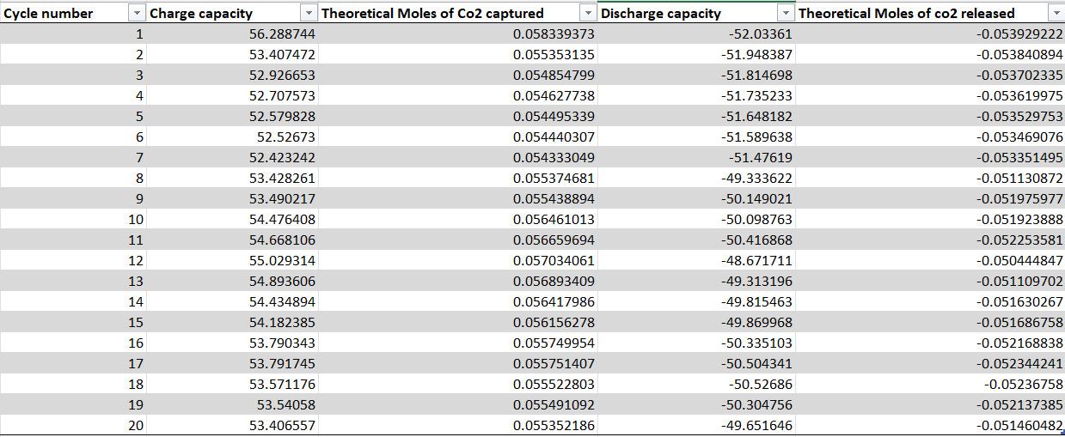

Replace the membrane and electrodes

Refresh the posolyte and negolyte

Fix the pump

Fix the tubing position

Make new solutions

One cycle under nitrogen

One cycle rest time 45 mins, 10 mins, and 30 mins 15 mins 0 mins triplicate

Gas ratio 1%, 5%, 10%,

c